**Asessment 1 PBW**

Nama : IGN Brindawan Tri Guna Yoga

NIM : 6706223062

Kelas : D3RPLA 46-04

File di Github ([GitHub - R1N-NY44/Asessment_6706223062_Brindawan](https://github.com/R1N-NY44/Asessment_6706223062_Brindawan))

**Asessment CLO 1 :**

1. **Instalasi Laravel**

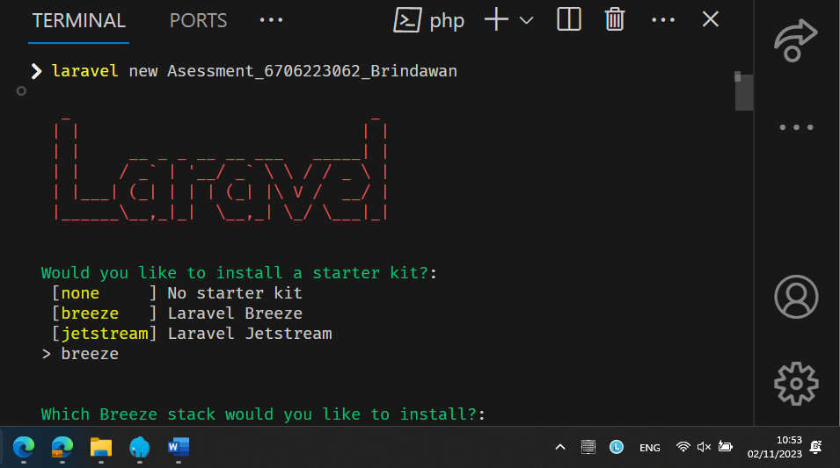

**Asessment CLO 2 :**

1. **Instalasi Breeze**

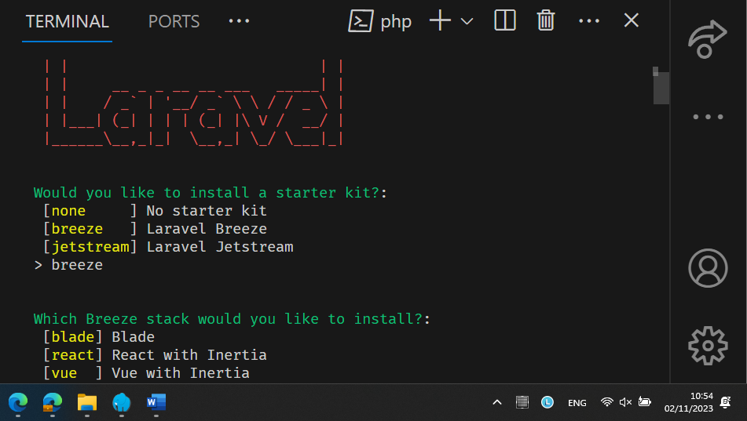

1. **Page utama setelah instalasi Breeze**

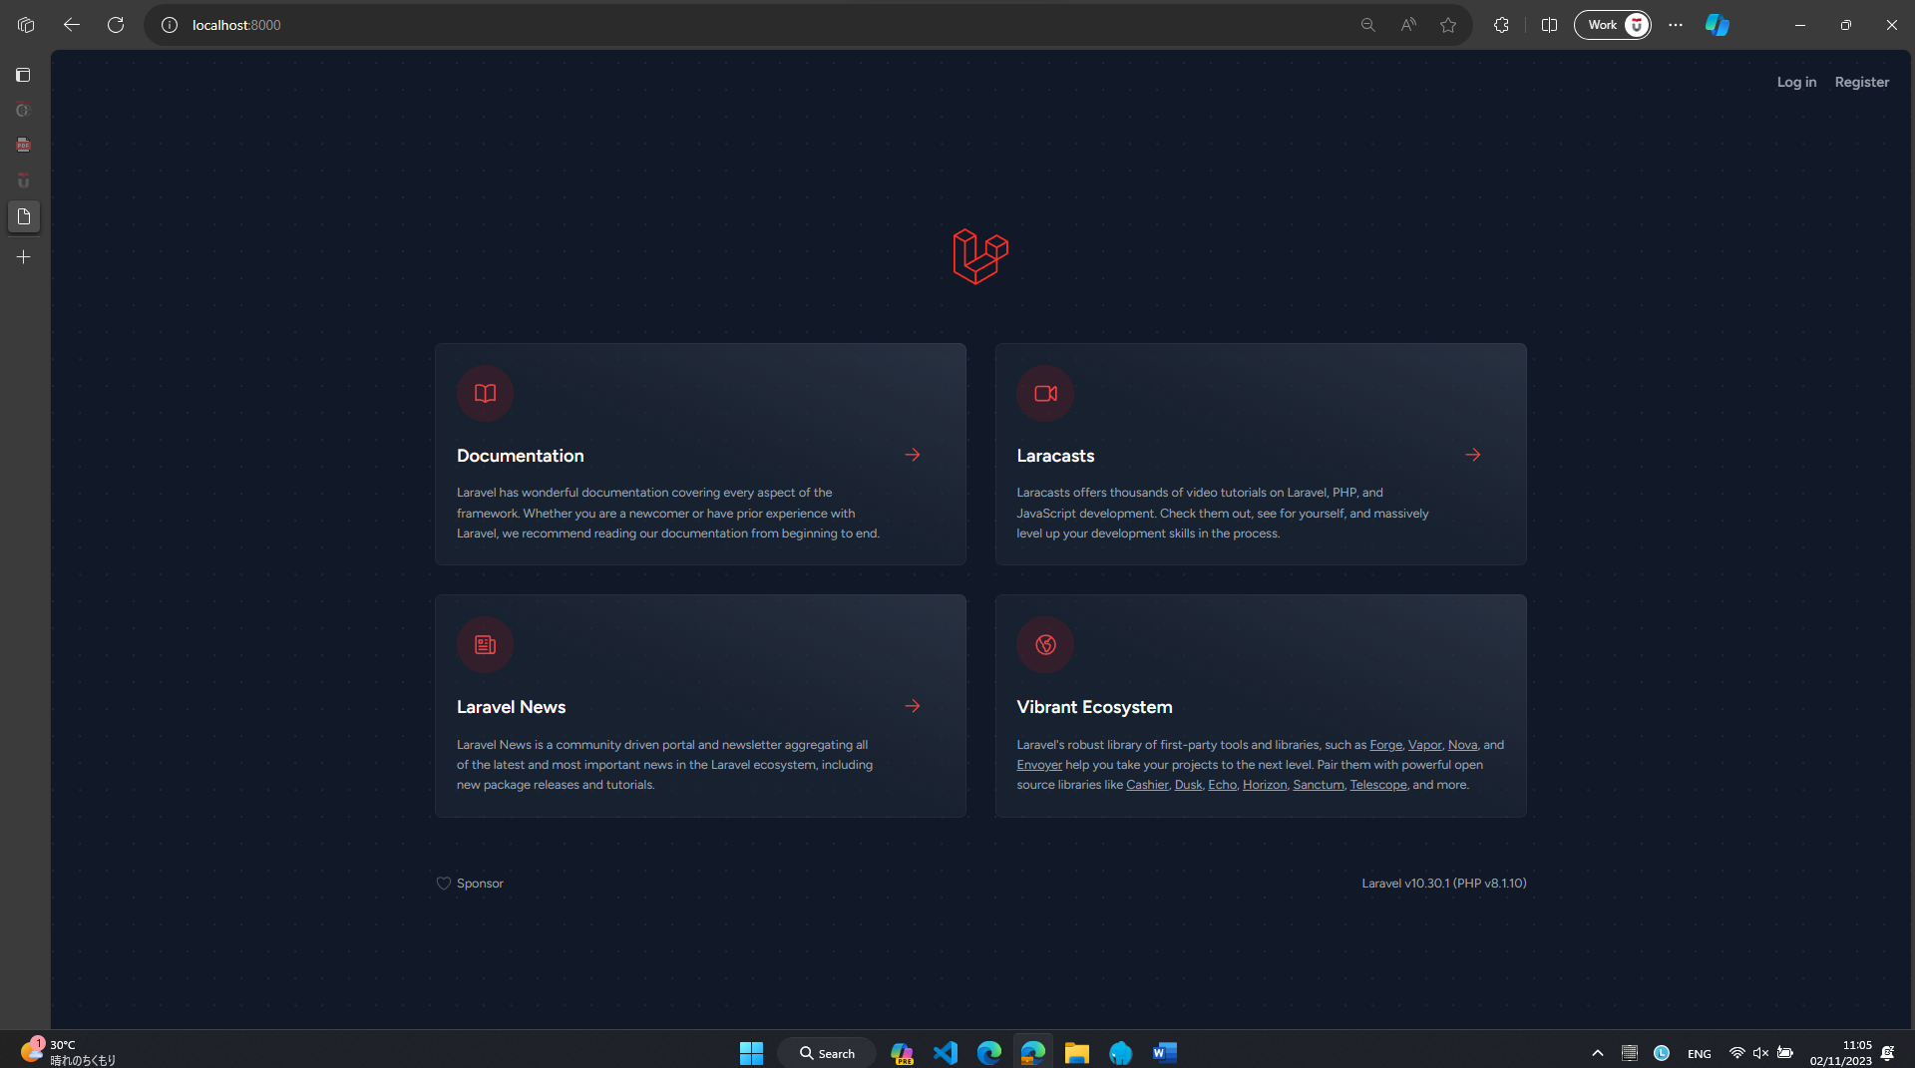

1. **Screenshot Register, Login dan Dashboard**
   1. **Register**

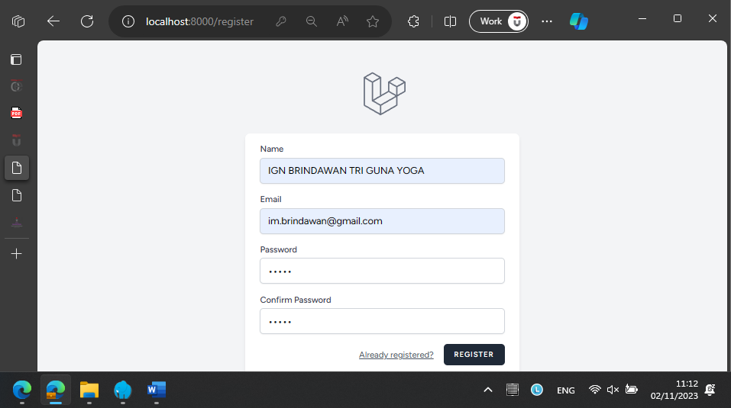

* 1. **Login**

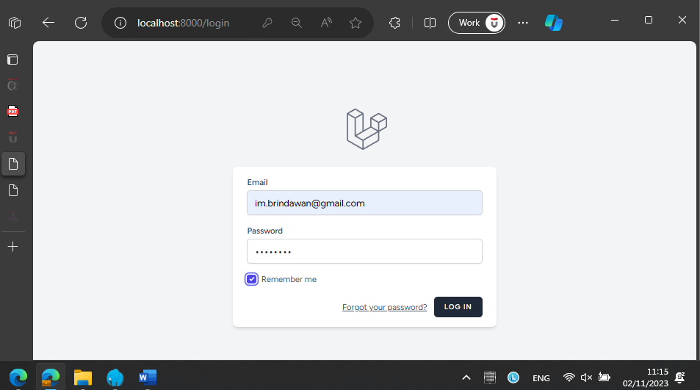

* 1. **Dashboard**

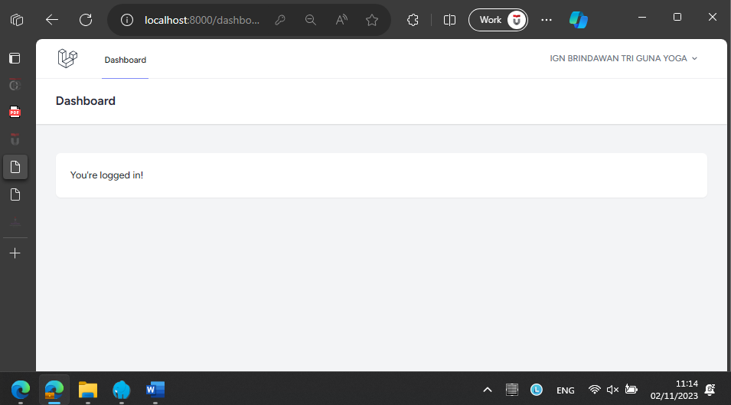

**Asessment CLO 3 :**

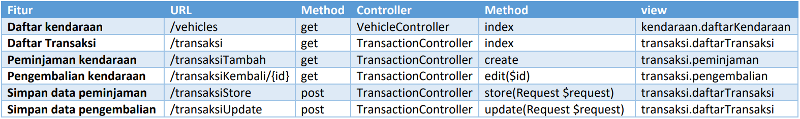

* **View Daftar Kendaraan**

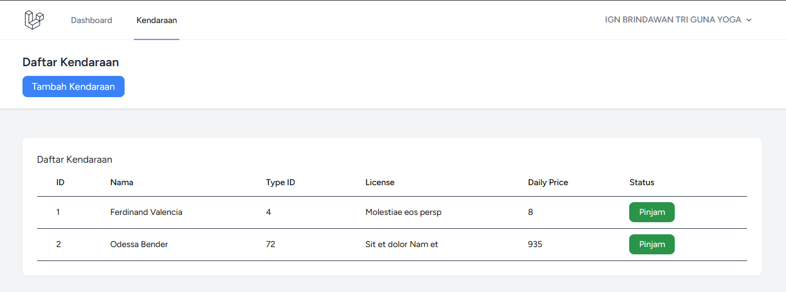

* **Route Kendaraan**

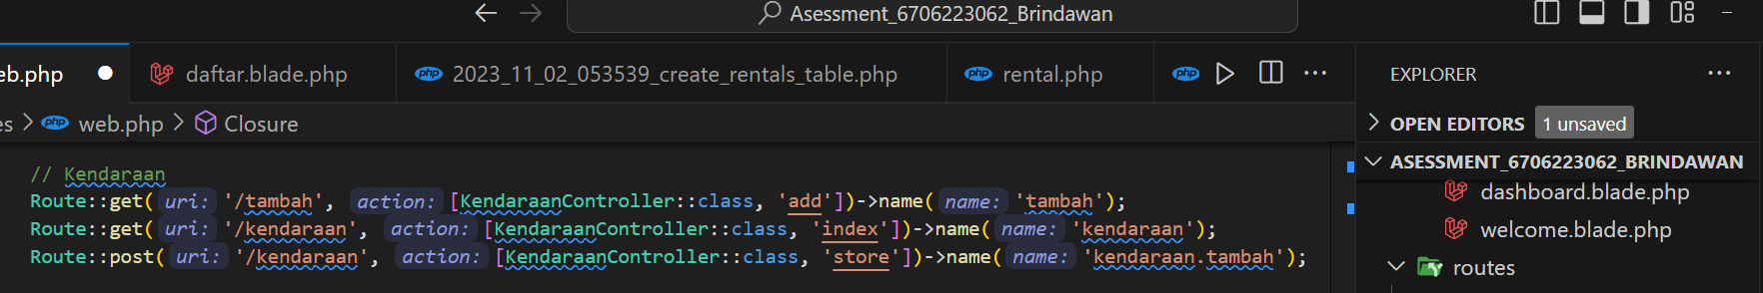

* **Controller Kendaraan**

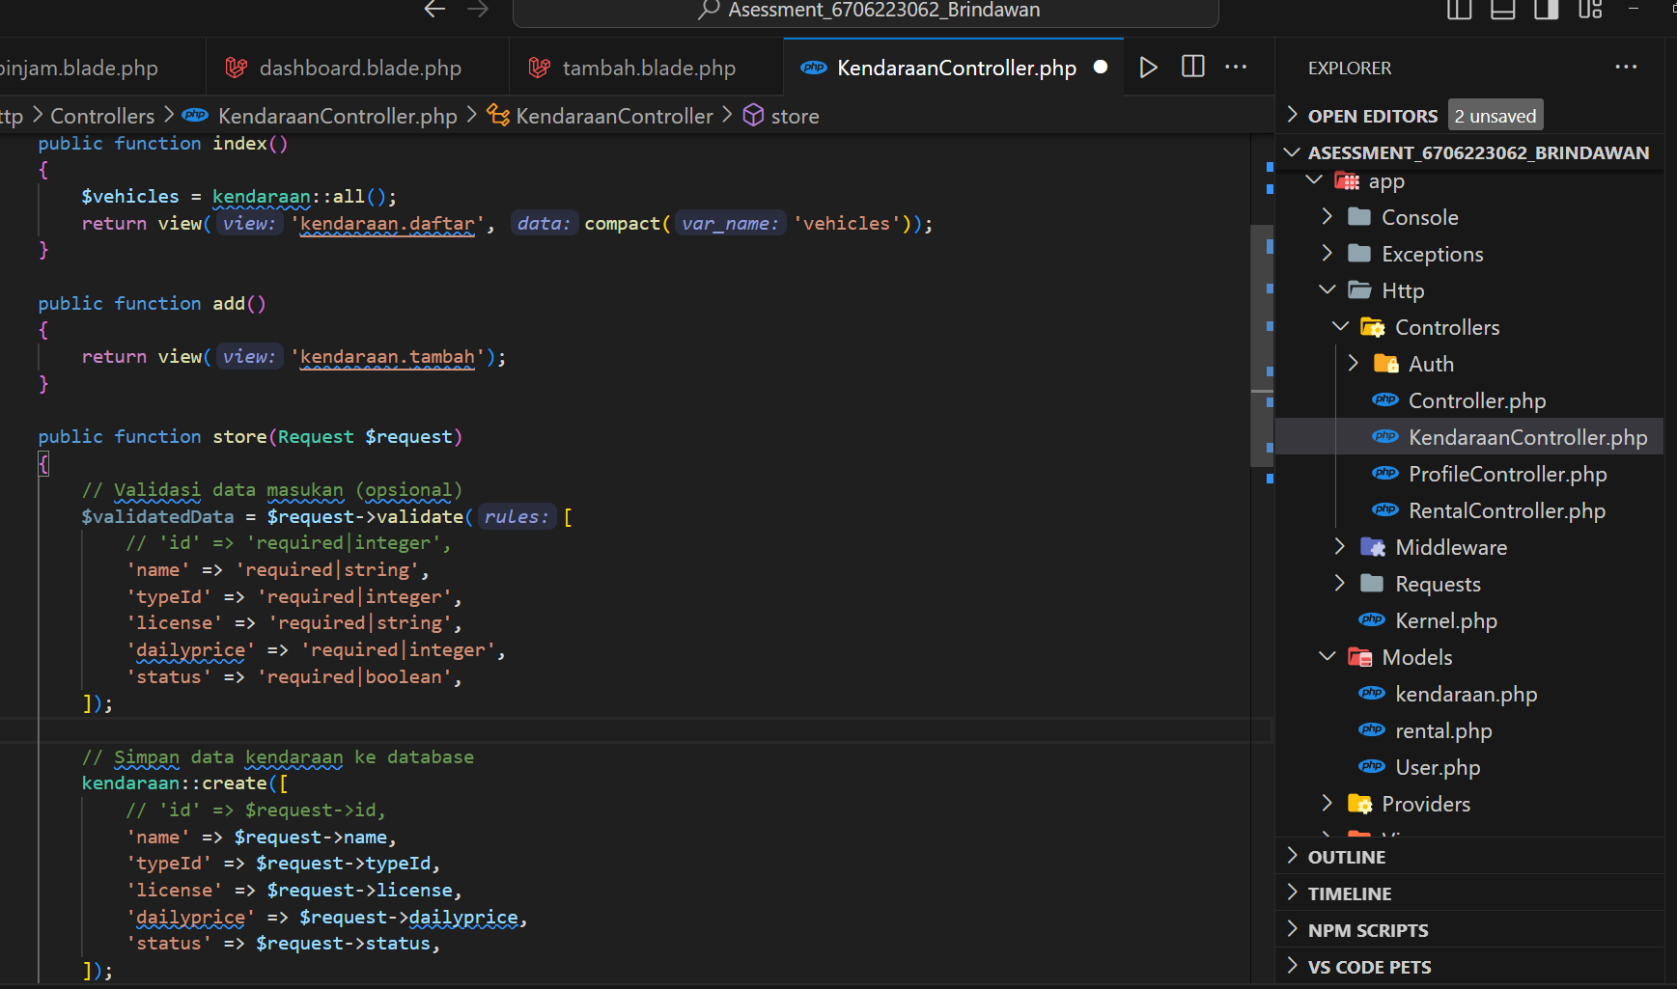

* **View Daftar Transaksi**

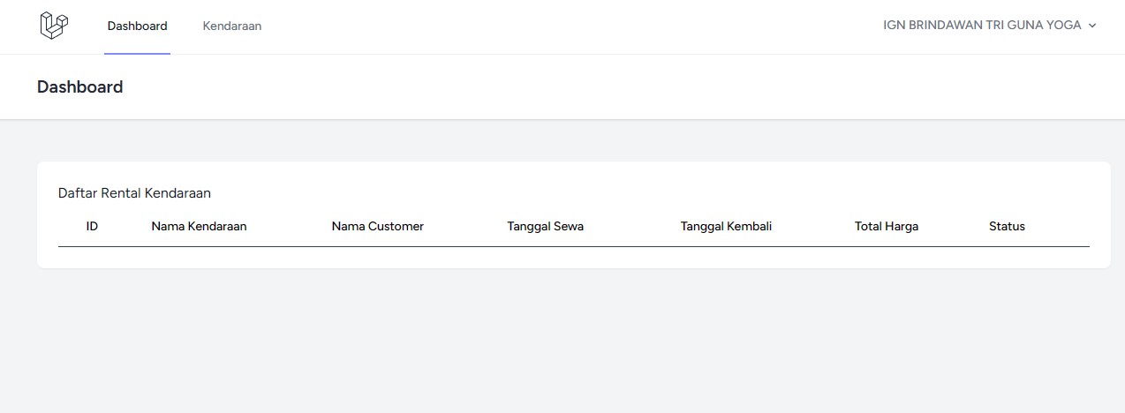

* **View Peminjaman**

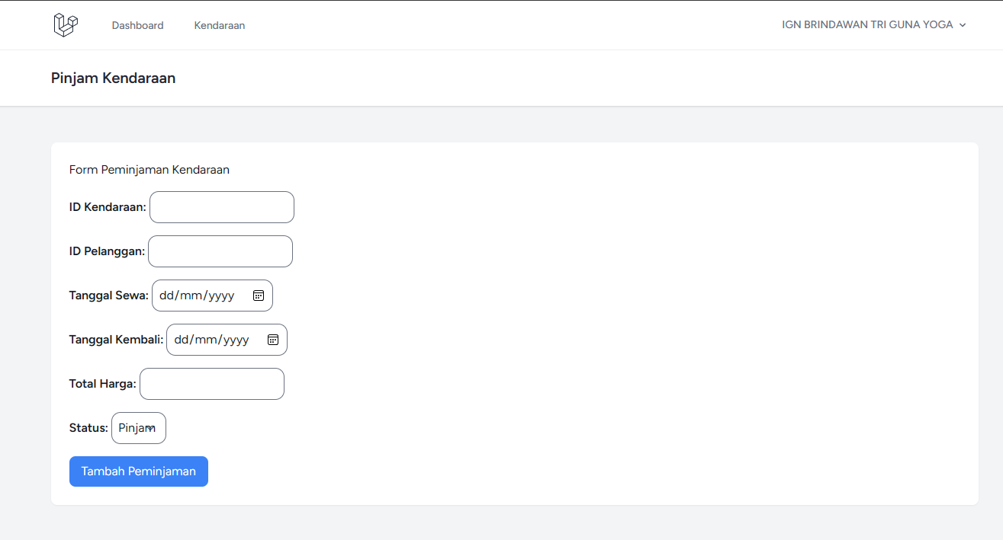

* **View Pengembalian**
* **Belum**